Landfill Methane Emission Tool How to guide.

Name: Nicholas Kinsella, Student number: B00893122

Table of Contents

1. Introduction and justification 1

2. Setup 2

2.1 Anaconda Navigator 2

2.2. Creating a Conda Environment 2

2.3 Setting up Jupyter Lab 4

2.4 openEO setup using Anaconda Navigator 6

2.5 openEO setup using PyPi 7

2.6 Registering with Copernicus Data Space Ecosystem. 8

2.7 Authentication with openEO 9

3. Methodology 10

4. Expected results 10

5. Troubleshooting 11

6. References 11

# 1. Introduction and justification

Methane (CH4) is the second most impactful greenhouse gas after carbon dioxide. Its warming potential is around 28 times more than CO2 over a 100-year period, although it is far less persistent in the atmosphere due to it being broken down by interaction with ultraviolet sunlight (Vigano et al., 2008). Despite this attrition, its concentration in the earth’s atmosphere has increased more than 250% since the industrial revolution and it is estimated to be responsible for at least a quarter of anthropogenic warming (Pandey et al., 2023).

Landfills are a significant contributor to global methane emissions du The 1999 EU Landfill Directive requires that methane produced by the anaerobic decomposition of organic waste is either collected for sale on the energy market, or is burnt off by flaring (European Union, 1999; Themelis & Ulloa, 2007). Despite this, methane plumes can still be produced if landfill conditions are mismanaged (Ferronato et al., 2017).

Spain sends more waste to landfills than any other country in the European Union at 12 million tonnes per year in 2017 (Grupo SPR, 2020) although on a per capita basis, it ranks 23rd in the block (Eurostat, 2022). Although the management of landfills in Spain is on par with countries like the UK, Ireland, Sweeden and Italy (Castillo-Giménez et al., 2019) unexpected emission events can still occur. In August and October 2021 two very large plumes of methane were detected by earth observation satellites from a landfill near Madrid. Had this gas been captured, it is estimated to have been enough to heat as many as 350,000 homes for a year (European Space Agency, 2021).

PreZero, a multinational waste management company, operates 23 landfill active and closed landfill sites across Spain. The author interviewed several of the staff regarding their practices and they currently do not use remote sensing platforms to monitor any CH4 emissions from their facilities, instead relying on ground-based detectors in a 1 detector per hectare grid (citation https://library-guides.ucl.ac.uk/harvard/personal-communication). These might potentially miss emissions from unforeseen locations, such as closed cells, or other areas away from the open face of the landfill.

The Copernicus Sentinel 5P (S5P) satellite CH4 dataset became available in 2021. Alowing daily readings of atmospheric methane concentrations globally and this was used in conjunction with the commercial GHGSat to detect the methane plumes near Madrid (European Space Agency, 2021).

A tool for displaying atmospheric CH4 data from S5P was created in the programming language Python. The tool displays a time series of CH4 values for each landfill location over a set of dates that can be specified by the user. If any emission events are detected, the tool can indicate how many days the emission persisted and then will display a map of the dataset for a specific day to allow visual assessment.

This guide outlines the installation and use of this tool. The most up-to-date version of it can be downloaded from the following Github repository: <https://github.com/zelcon01/egm722>.

# 2. Setup

Anaconda Navigator is an application that contains the Python programming language along with the additional tools, libraries and utilities. Within Anaconda lies the package manager ‘Conda’ which allows the end user to create a shareable development environment containing the necessary packages to run a particular script, including Jupyter Lab, where the Python code itself will be ran. We will be installing these in this section.

## 2.1 Anaconda Navigator

To download Anaconda, navigate to <https://docs.anaconda.com/anaconda/install/> and follow the instructions of your associated operating system.

## 2.2. Creating a Conda Environment

In the Anaconda Navigator side bar, click the ‘Environments’. You will see the installed packages (fig.1).

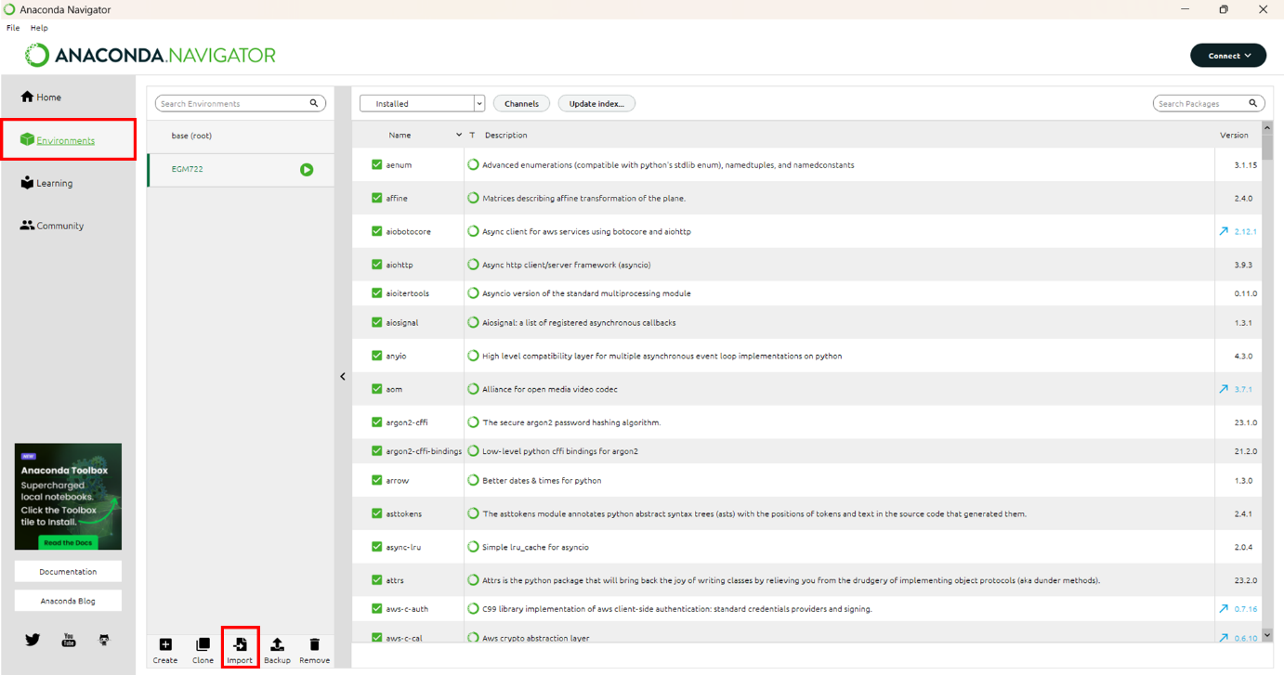

Figure 1: Environments tab of Anaconda Navigator with environments tab and import button highlighted in red.

Next click on the imports tab (fig.1) and select the file ‘environment.ymal’ contained in the .zip file of the tool’s download, choosing an appropriate name for the environment (fig.2).

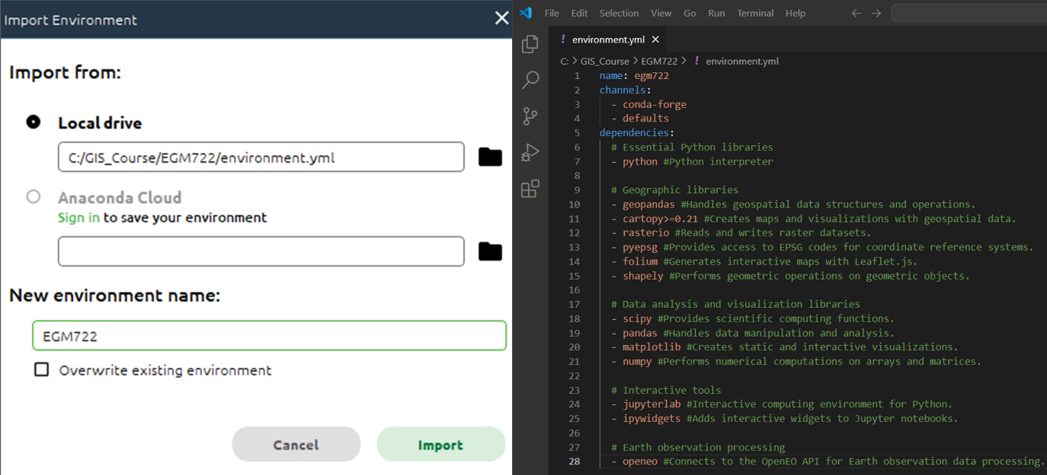

Figure 2:The import config box (left) and the contents of ‘environment.ymal’ (right).

Click Import. Depending on the connection speed of your network, the process of installing all the packages may take several minutes. Once the installation is finished you will be returned to the environments tab (fig.1) and you should see that over 160 packages have been installed.

Next click on the ‘Home’ tab in Anaconda Navigator’s sidebar (fig.3).

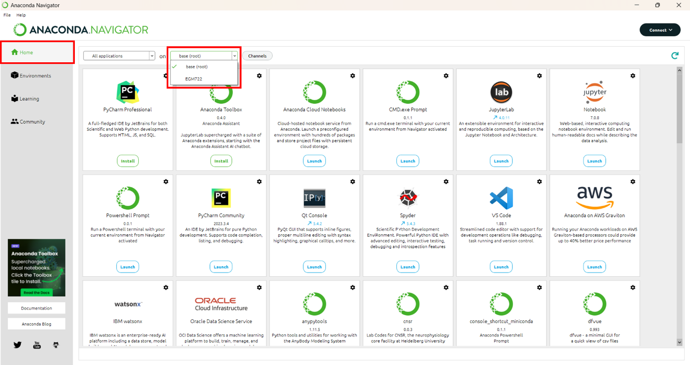

Figure 3: Anaconda Navigator with home tab and environment switching dropdown in red.

The dropdown highlighted in figure 3 should display two options, ‘base (root)’ and the name of your new environment (in figure 3 this is ‘EGM722). **When running the startup process it is essential that your environment name is selected here or the dependencies we installed earlier will not be available to it.**

## 2.3 Setting up Jupyter Lab

A configuration file (‘.config’) needs to be created to change the settings used by Jupyter Lab by default. To do this, launch the CMD.exe Prompt, ensuring that your new environment is selected (fig.4)

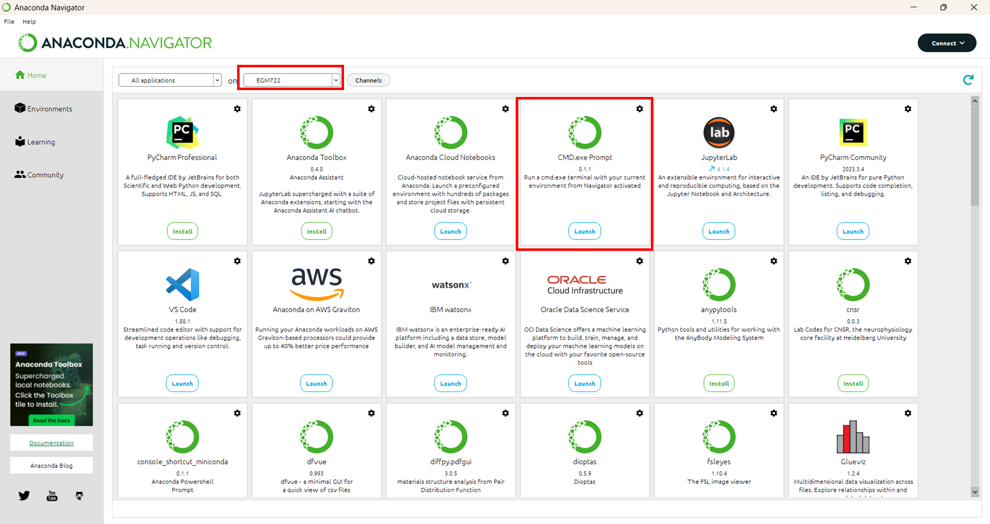

Figure 4: Highlighted locations of selected environment and CMD.exe Prompt

In the command prompt, enter the command:

|  |
| --- |
| jupyter lab --generate-config |

This will create a new folder in your user directory called ‘.jupyter’ containing a python script juptyer_lab_config.py. On Windows this is usually C\Users\<your_username>.

Jupyter lab will by default open in your user directory. Unfortunately due to security restrictions it isn’t possible to navigate to the parent directory of the launch location. So if Jupyter launches in ‘C:\Users\RockyBalboa, it isnt’ possible to move to ‘C:\Users’ or, ‘C:\EGM722’ for example. If the directory you are keeping your data in is outside your user directory, you will need to change the default opening folder to your data directory.

If your data directory is in your user directory, you should be able to click and navigate there using the interface of Jupyter Lab. If that isn’t the case, you will need to do the following:

Open an Anaconda Navigator CMD.exe prompt (remembering of course to activate your new environment before launching it) and type the following command:

|  |
| --- |
| jupyter --paths |

This will show something like figure 5 although your file paths will be unique to you.

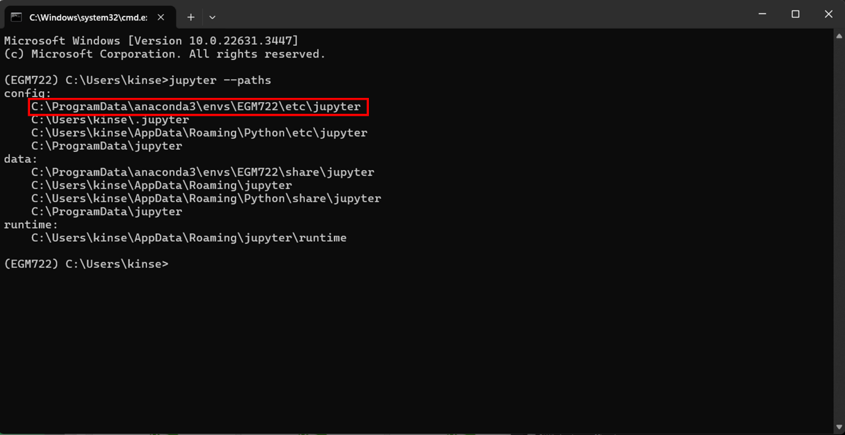

Figure 5: results of ‘jupyter –paths’ command showing path used by environment highlighted in red.

The ‘jupyter_lab_config.py’ file mentioned earlier needs to be copy pasted into that folder.

Once ‘jupyter_lab_config.py’ file has been moved, open it in Notepad++, Visual Studio Code or if you don’t have those, Notepad will do. Using the shortcut ‘CTRL + F’ type in the following line of code: ‘c.ServerApp.root_dir’ and you should find the section highlighted in figure 6.

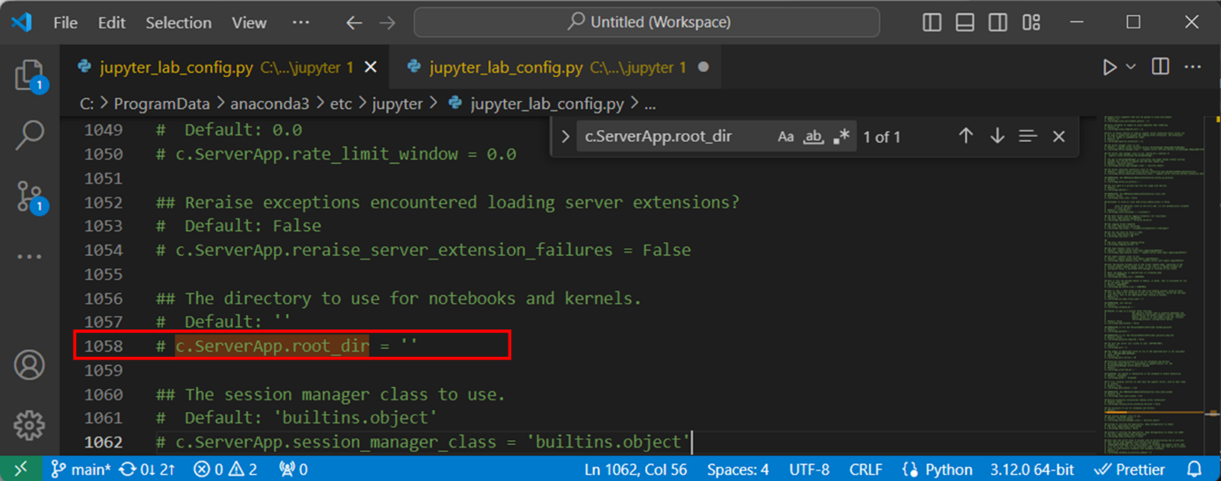

Figure 6: location of 'c.ServerApp.root_dir' in jupyter_lab_config.py

Remove the ‘#’ and space from the start and add the path used by your environment between the quote marks, adding a ‘r’ beforehand (fig.7).

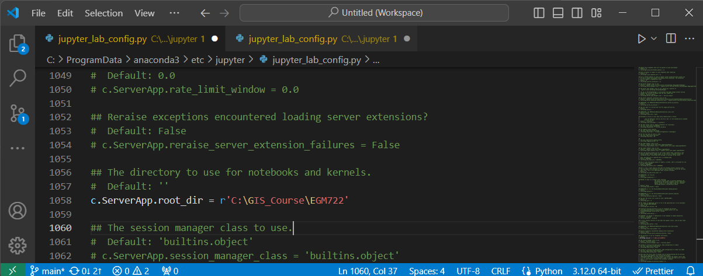

Figure 7: path to data directory added to jupyter_lab_config.py

Save and close this file and return to the Anaconda Navigator ‘Home’ tab. Launch Jupyter Lab and if you have followed the steps correctly, you should see that your data directory is automatically displayed (figure 8).

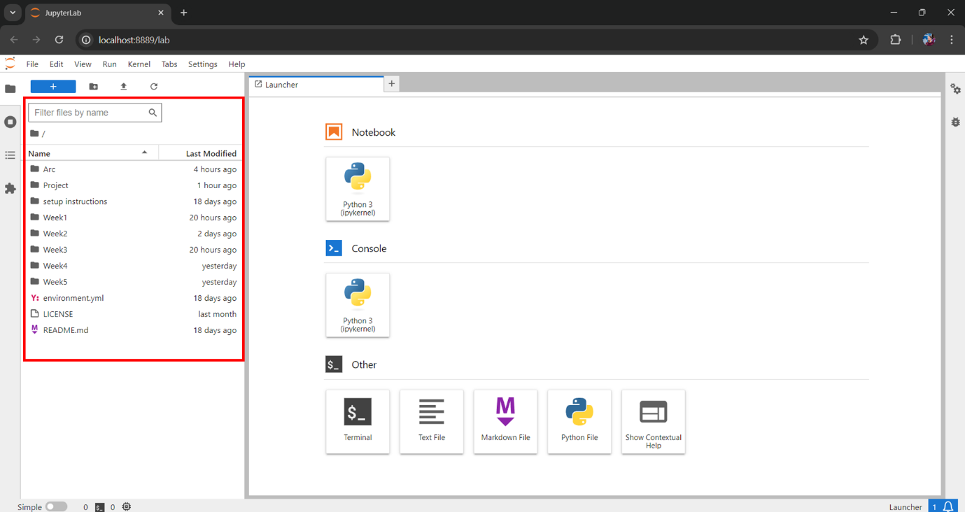

Figure 8: Jupyter Lab showing by default the data directory

### 2.4 openEO setup using Anaconda Navigator

openEO is an open-source API that allows access to the earth observation satellite missions provided by the Copernicus program. These include Sentinel series of satellites used by this tool.

To install openEO you can first search in the Anaconda Navigator environments tab for ‘openeo’. Make sure that ‘Not installed’ is selected (fig.9). If the package appears here, click its tick box and select apply.

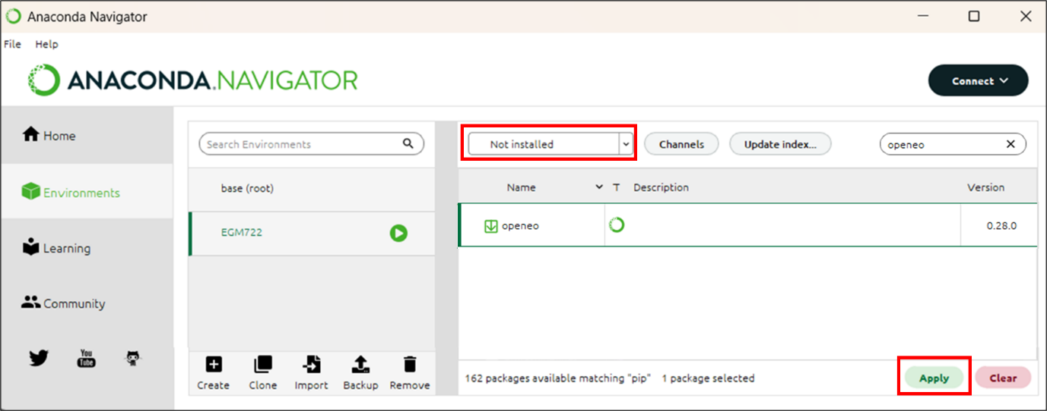

Figure 9: installing openEO from Anaconda Navigator.

Next you will be presented with the following screen (fig.10). One this has finished processing the request. Simply click ‘apply’ to begin the installation.

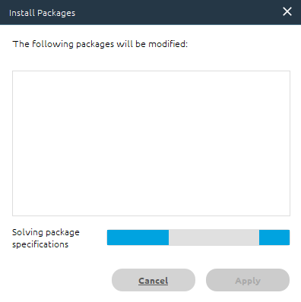

Figure 10: Anaconda Navigator package installer loading screen.

## 2.5 openEO setup using PyPi

In the event that Anaconda Navigator cannot find openEO you can use PyPi, the official third-party software library for Python.

Using the search function in the Anaconda Navigator Environments tab, search for ‘pip’, selecting the appropriate tick-box and then clicking apply (fig.11), then clicking apply once the install packages prompt (fig.10) has finished loading.

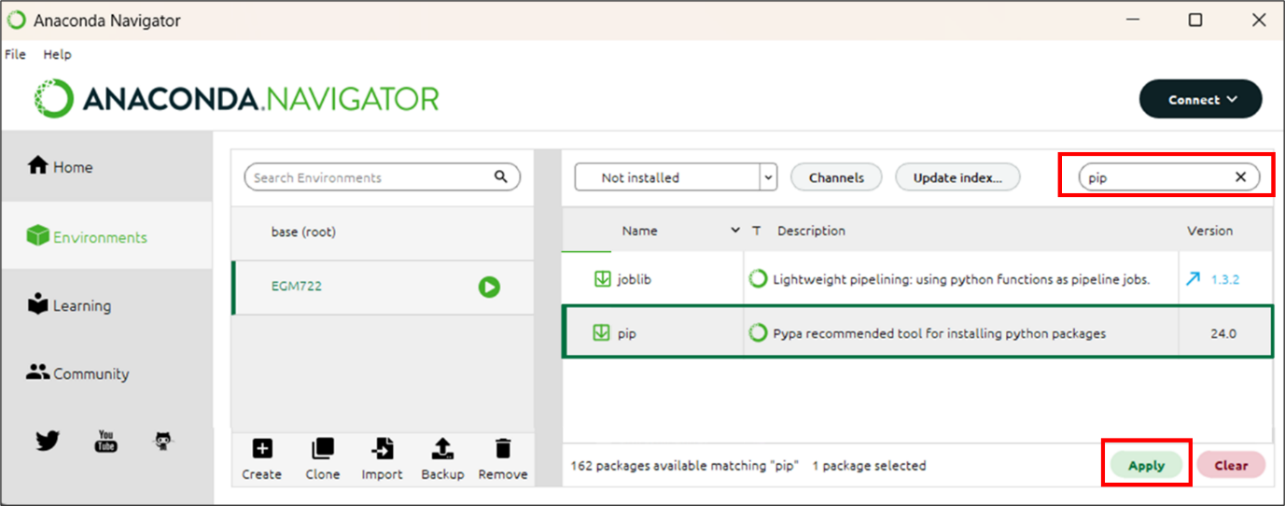

Figure 11: Installing pip via Anaconda Navigator

Open an Anaconda Navigator CMD.exe prompt (remembering as always activate your new environment before launching it) and type the following command.

|  |
| --- |
| pip install openeo |

Once this has completed you can close the CMD.exe prompt window.

## 2.6 Registering with Copernicus Data Space Ecosystem.

Although it is possible to browse openEO metadata without being logged in. Accessing and analysing openEO data requires an authentication. To do this, you need to complete a Copernicus Data Space Ecosystem Registration. Go to https://dataspace.copernicus.eu/ and click the green login button (fig.12)

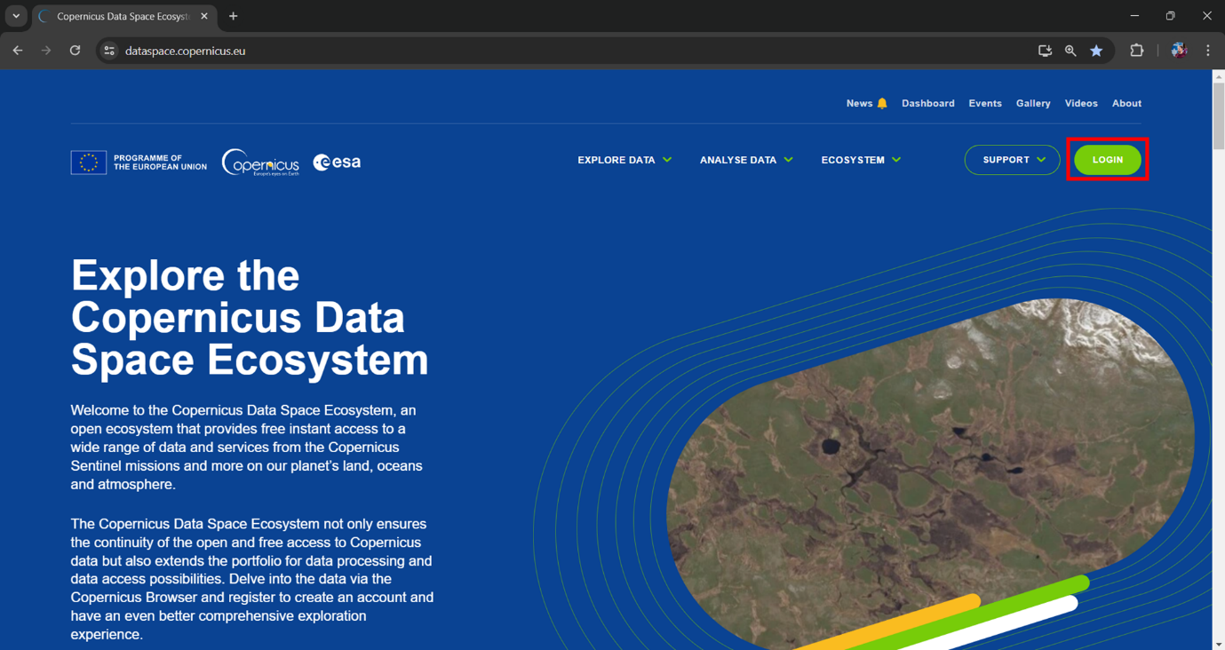

Figure 12: Copernicus Dataspace landing page with login button highlighted in red.

Next click the green ‘register’ button:

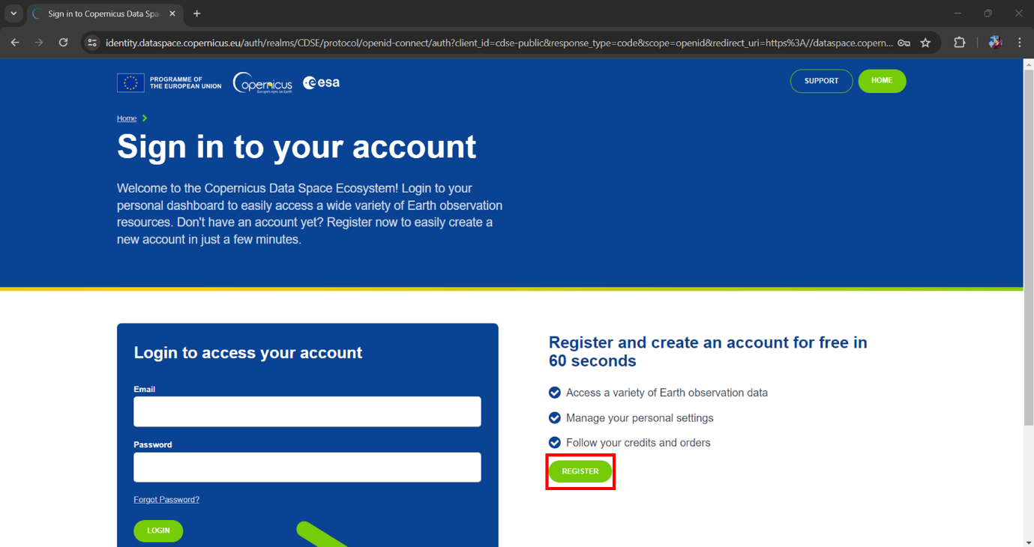

Figure 13: Copernicus Dataspace sign in page.

On the following page, fill out the application form and then at the bottom, complete the prompt to show that you are not a robot and then the green ‘register’ button (fig.14).

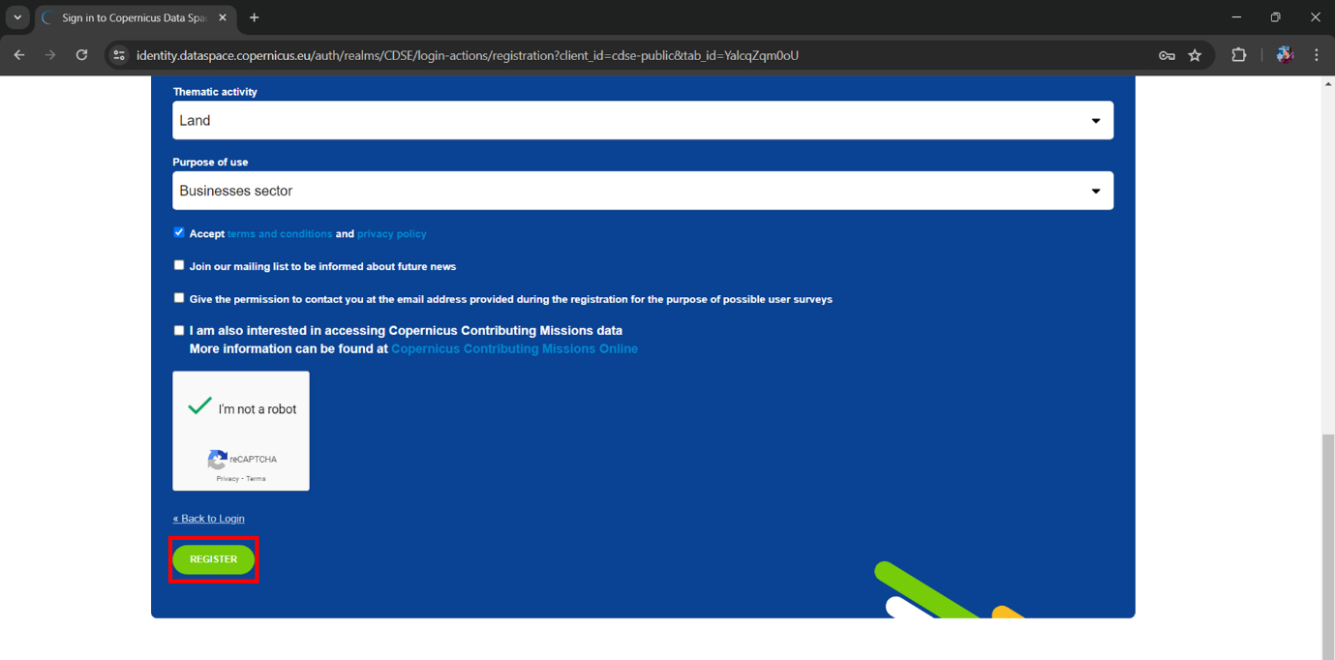

Figure 14: End of Copernicus registration page with register button highlighted in red.

Once registered, you will receive an email asking to verify your address. Click the ‘verify email address’ button as soon as you receive it. The registration process will then be complete and you can log-in with your email and chosen password.

Should you have any problems with registration, you can email help-login@dataspace.copernicus.eu

## 2.7 Authentication with openEO

The very first time the tool is run, the following section of code…

|  |
| --- |
| connection = openeo.connect(url="openeo.dataspace.copernicus.eu")  connection.authenticate_oidc() |

… will provide you with a URL that will look something like this:

|  |
| --- |
| Visit https://auth.example.com/device?user_code=EAXD-RQXV to authenticate. |

You need to copy this URL into your web browser and login using the Copernicus Data Space Ecosystem email and password. Once this is complete, run tool’s Pyhton script again and it will receive an authentication token, printing the message:

|  |
| --- |
| Authorized successfully. |

In future you may be prompted with a new URL to create a new authentication token, whereby you should repeat the steps of this section (2.7).

# 3. Methodology

The tool takes its primary data from the Copernicus Sentinel 5P CH4 dataset which became available in 2021. This dataset provides daily methane measurements at a spatial resolution of 5.5 x 3.5km

The tool makes a timeseries of methane emissions for all 23 sites, displaying these on a chart allowing the user to see how many days an emission event lasts.

The tool then allows the end user to see a map of the methane data for a specific date over a specific landfill. Spatial statistics are then provided to estimate the peak level of methane in parts per billion as well as the average of the plume.

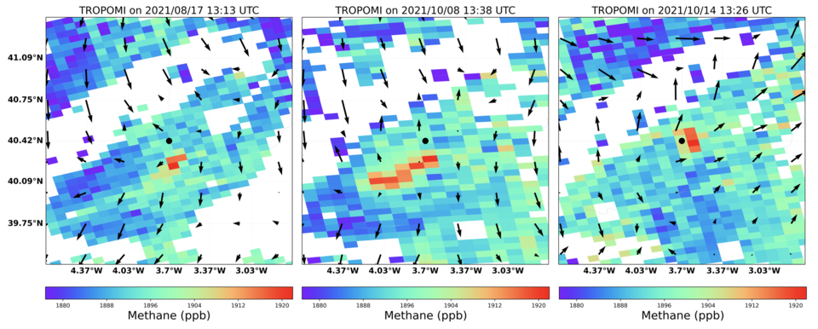

A methods section that clearly explains what your code does – if you’re performing a certain kind of analysis, this should explain the steps of the analysis and the theory behind it. This section should be written in the style of a methods section for a journal article or technical report.

# 4. Expected results

A section that explains the expected result of running your code.

# 5. Troubleshooting

A section that provides some troubleshooting advice in case things go wrong.

In the event that you get the following error:

|  |
| --- |
| OpenEoApiError: [400] ConcurrentJobLimit: Job was not started because concurrent job limit (2) is reached. (ref: r-240413b5d1b240118da9f9ed90807c58) |

This can happen when the tool is run, cancelled and then run again. If this happens the process is still running in the background and needs to be cancelled.

To do this go to the following URL: <https://openeo.dataspace.copernicus.eu/>

You will be presented with the following screen (fig.?)

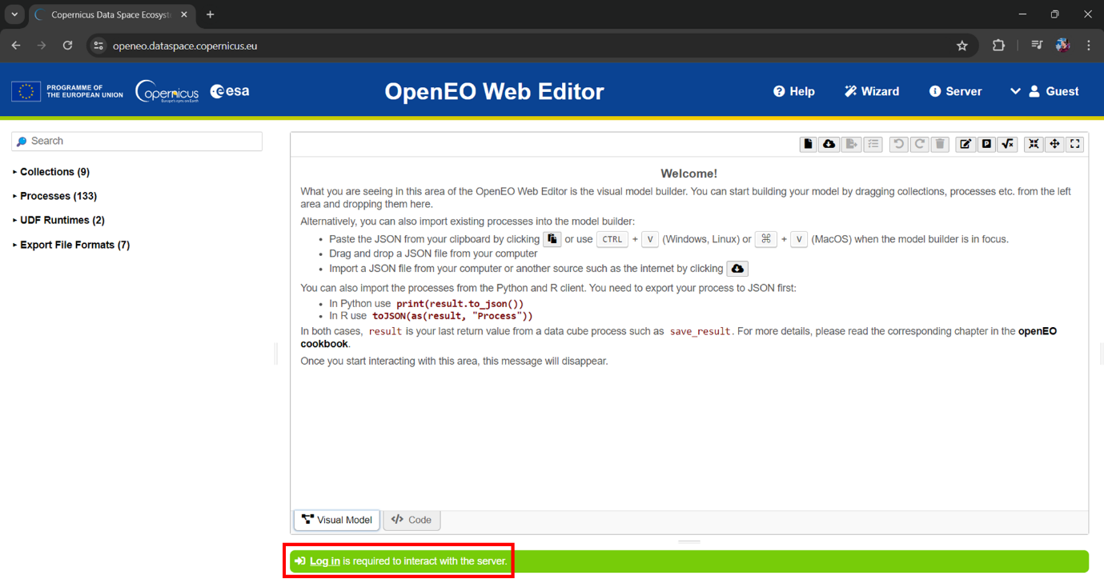

Figure 15: OpenEO Web Editor with login button highlighted in red

You will then see the following screen.

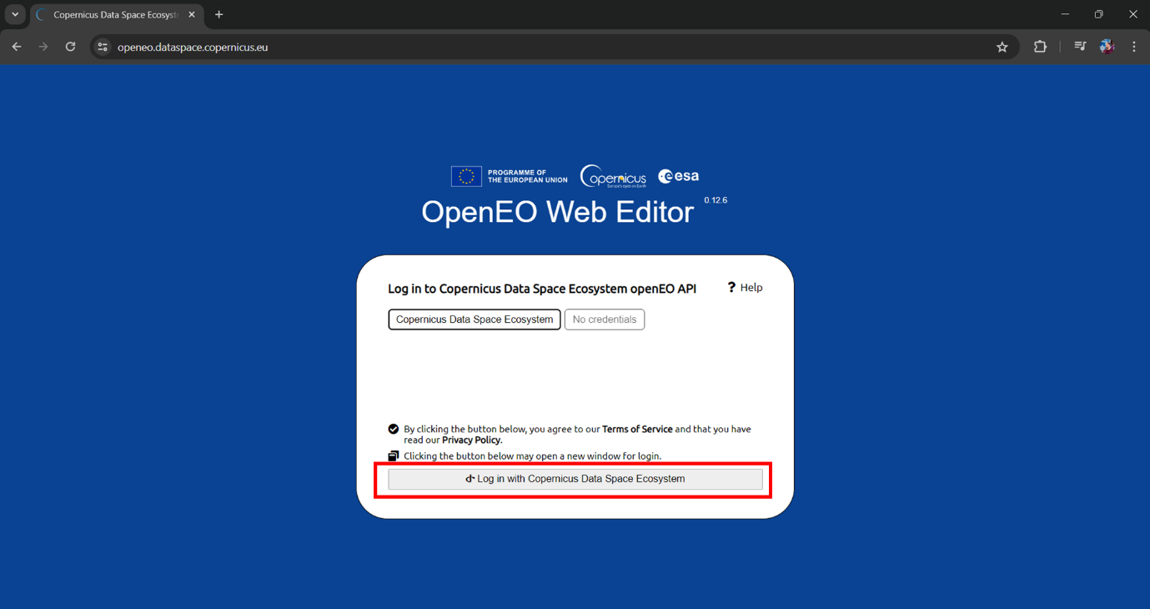

Figure 16: OpenEO Web editor login prompt with login button highlighted in red.

Simply click the highlighted button and follow the process. You should then be returned to the OpenEO web editor but now you will see a list of processes including the active ones.

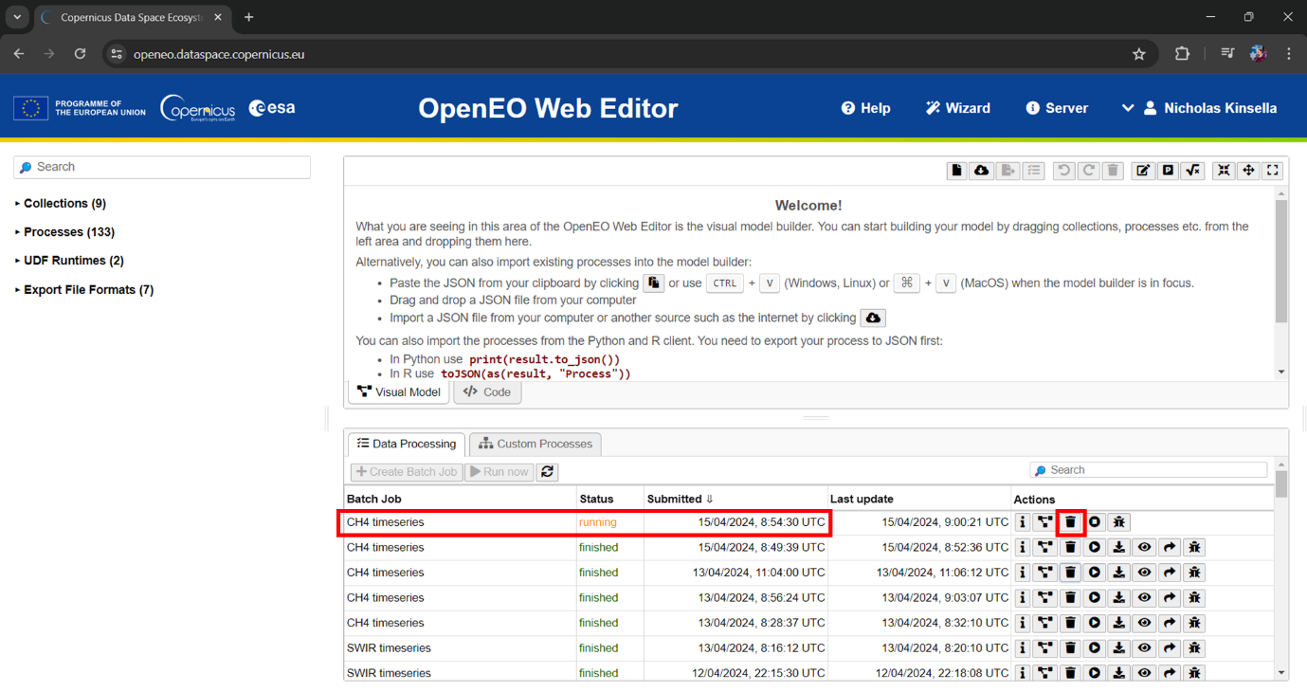

Figure 17: OpenEO Web Editor showing batch job screen, with running job and delete button highlighted.

To stop the process, simply click the highlighted bin button (delete). This should allow the tool to work normally again.

# 6. References

Castillo-Giménez, J., Montañés, A., & Picazo-Tadeo, A.J. (2019). Performance in the treatment of municipal waste: Are European Union member states so different? Science of the Total Environment, 687, 1305-1314.

European Union. (1999). Council Directive 1999/31/EC of 26 April 1999 on the landfill of waste. Retrieved April 14, 2024, from: https://eur-lex.europa.eu/eli/dir/1999/31/2018-07-04

European Space Agency (2021) Satellites detect large methane emissions from Madrid landfills. Available at: https://www.esa.int/Applications/Observing_the_Earth/Satellites_detect_large_methane_emissions_from_Madrid_landfills (Accessed: April 11, 2024).

Eurostat. (2022). Municipal waste statistics. Retrieved April 14, 2024, from: https://ec.europa.eu/eurostat/statistics-explained/index.php?title=Municipal_waste_statistics

Ferronato, N., Torretta, V., Ragazzi, M., & Rada, E.C. (2017). Waste mismanagement in developing countries: A case study of environmental contamination. UPB Sci. Bull, 79(2), 185-196.

Grupo SPR (2020) Spain is the European country that throws the most waste into dumps. Available at: https://www.grupo-spr.com/en/spain-waste-dumps/ (Accessed: April 11, 2024).

Pandey, S., van Nistelrooij, M., Maasakkers, J.D., Sutar, P., Houweling, S., Varon, D.J., Tol, P., Gains, D., Worden, J., & Aben, I. (2023). Daily detection and quantification of methane leaks using Sentinel-3: a tiered satellite observation approach with Sentinel-2 and Sentinel-5p. Remote Sensing of Environment, 296, 113716.

Themelis, N.J. and Ulloa, P.A. (2007). Methane generation in landfills. Renewable Energy, 32(7), 1243-1257.

Vigano, I., Van Weelden, H., Holzinger, R., Keppler, F., McLeod, A., & Röckmann, T. (2008). Effect of UV radiation and temperature on the emission of methane from plant biomass and structural components. Biogeosciences, 5(3), 937-947.